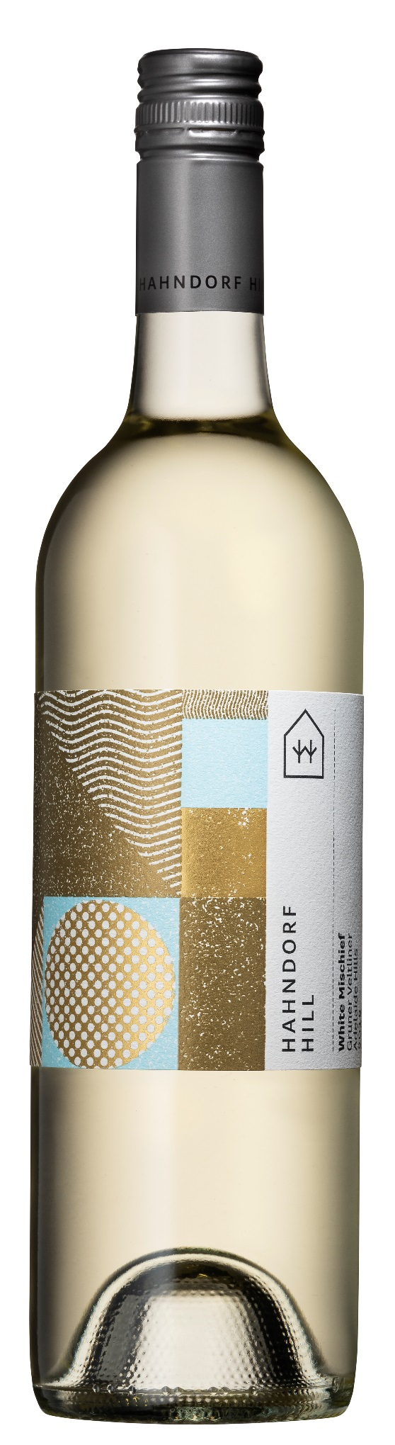

ADELAIDE HILLS

**White Mischief**

**Gruner Veltliner 2022**

Gold Medal – Australian Cool Climate Wine Show 2022

Gold Medal – Australian Small Winemakers Show 2022

Gold medal – Adelaide Hills Wine Show 2022

White Mischief is our our exciting **New World** version of Gruner Veltliner, made using New-World technology which encourages the full range of exotic, primary fruits** that this variety can offer, to be fully expressed in the wine.

The nose is bursting with enticing citrus, stone fruit and exotic tropical aromatics and the palate is a vibrant tumble of ruby grapefruit, nectarine, mango and guava. This is all balanced with a delicious, juicy acidity and the all-important textural**-rub** (that comes from soft tannin phenolics that is typical for this variety) which is an important feature of all our Gruner styles.

Perfect with all Asian cuisine, all white meats, vegetarian dishes, seafood, and soft cheeses.

**Lab Data:**

pH 3.24

TA 6.0 G/L

Resid.sugar 1.7 G/L

Alcohol 13.5%

** **Some notes for Sara**: Gruner Veltliner is primarily an aromatic variety which, depending on the farming practices, wine making practices and terroir, will have the ability to express a range of the following aromatics and flavours:

**Citrus**: Lime-peel, lemon, mandarin, ruby-grapefruit & grapefruit pith

**Yellow stone fruits**: especially nectarine, but occasionally peach, apricot

**Pear/Apple**

**Tropical**: Guava, mango, pineapple

**Vegetal**: Green tobacco (like rollie tobacco), parsnip

**White pepper** (Rotundone) – Although many books still reference that white pepper is typical of Gruner Veltliner, in reality it’s seen less and less over the past 2-3 decades - (? due to farming practices, clonal selections, climate change). It is now more common to see a general ‘spiciness’ rather than a specific white pepper.