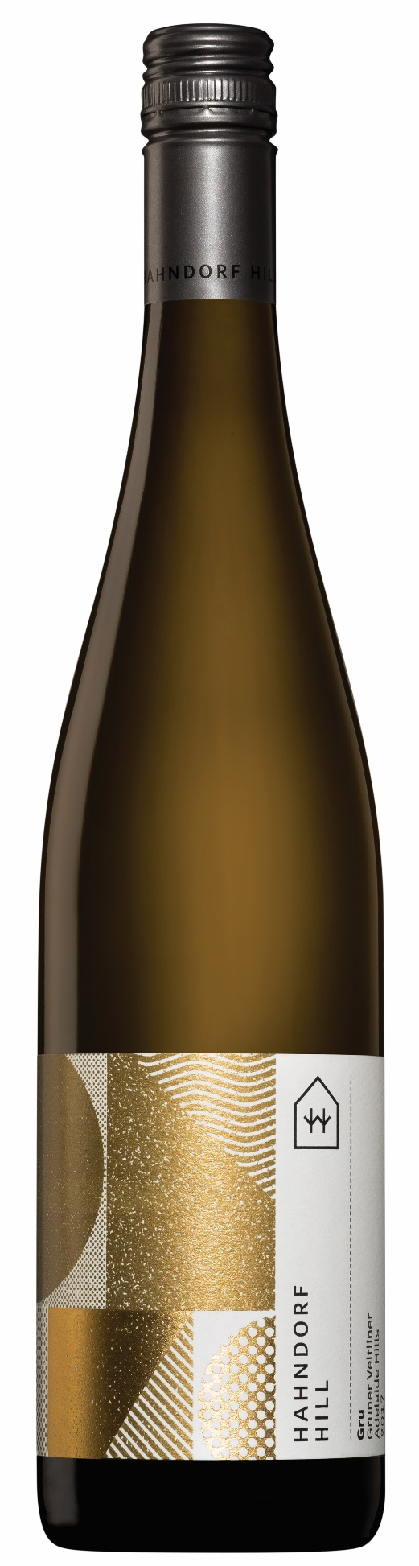

ADELAIDE HILLS

**Gru Gruner Veltliner 2023**

Brand New Vintage Release!

Trophy + Gold Medal – Australian & New Zealand Boutique Wine Show 2023

Double Gold Medal – Global Fine Wine Challenge 2023

Gold Medal – Royal Hobart Wine Show 2023

Gru is our **Classic** style of Gruner Veltliner where there is equal focus on the savoury components, the primary fruit aromatics and the texture/ spicy mouth-feel elements.

Perfumed nose with peach, lime peel and chamomile. The palate is brimming with yellow-fleshed peach, grapefruit and an edge of guava, all framed by a juicy, limey acidity and a mouth-filling texture. This wine has a long, flavoursome finish with on-going layers of delicious texture and spice.

Gruner Veltliner is one of the best food wines in the world, and can be enjoyed with just about everything! Perfectly paired to all seafood, white meats, South East Asian cuisine, vegetarian dishes – and it’s the perfect white wine for rare, red meats!

Gruner Veltliner is a variety that ages well and this wine should develop superbly for between 7 - 12 years.

**Lab data:**

**pH 3.22**

**TA 6.0 G/L**

**Residual sugar 1.04 G/L**

**Alcohol 13.0%**