

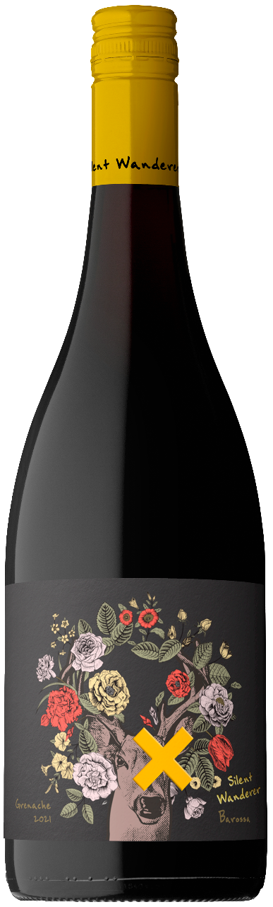

**2021 Silent Wanderer Barossa Grenache**

Silent Wanderer inspires wine lovers and fringe seekers alike! Enticing experience seekers with aromas and flavour intensity rarely found across the wide world of wine. Inspired by the dark & edgy fringes of brand culture yet balancing that energy with vibrant bold design features. This brand targets a high worth consumer looking for something of higher quality but elements of culture and art.

**REGION**

Barossa Valley.

**VINTAGE CONDITIONS**

The 2020/2021 growing season in the Barossa began with warm conditions and average rainfall. After two consecutive years of extreme weather conditions at flowering, late spring of 2020 was calm and uneventful. This allowed great fruit set and healthy canopies carrying slightly above average crop load. Some well timed rainfall in late January replenished the soil profile before a cool, dry March allowed slow and steady ripening.

**WINEMAKING & MATURATION**

The wine was fermented on skins for ten days, utilizing a small percentage of whole bunch fermentation in open fermenters, and then aged in mix of French and American oak for 14 months prior to bottling.

**COLOUR**

Translucent, limpid crimson ruby hue to the rim.

**NOSE/ AROMA**

Dark cherry to candied cherries, raspberry, smoke, coffee grounds and bitter dark chocolate, with a note of orange peel and a whiff of vanilla.

**PALATE**

Medium bodied, juicy fruit driven. Plump ripe cherries, strawberries and blueberry with a little fresh thyme giving a savoury, and herb note. Good, fresh, mouth-watering acidity, and ultra-fine tannin grip. Finishes dry, with a little white peppery spice.

**ANALYSIS**

**Alc/Vol** 14.5% **T.A** 5.96g/L **pH** 3.48 **RS (Glucose & Fructose)** 0.44g/L

**PEAK DRINKING**

Ready to enjoy fresh, or can be cellared until 2028.

**ENJOY**

Served with Poultry , BBQ sausages, fish like Barramundi or salumi/charcuterie.