

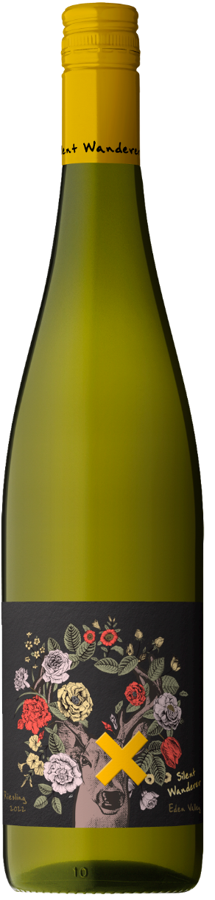

**2022 Silent Wanderer Riesling**

Silent Wanderer inspires wine lovers and fringe seekers alike! Enticing experience seekers with aromas and flavour intensity rarely found across the wide world of wine. Inspired by the dark & edgy fringes of brand culture yet balancing that energy with vibrant bold design features. This brand targets a high worth consumer looking for something of higher quality but elements of culture and art.

**REGION**

Eden Valley, South Australia

**VINTAGE CONDITIONS**

The 2021/2022 growing season was a tale of two quite distinct periods. From budburst up until the early stages of veraison we encountered quite unpredictable and volatile weather. A cool and wet start to the season was followed by two significant hail events and then several weeks of higher than average humidity. Towards the end of January conditions became much more stable with mild, dry days and cool nights becoming the normal. With no extreme heat events at all during the final stages of ripening we were able to make decisions regarding harvest dates purely on fruit quality rather than environmental pressures. Harvest of Eden Valley Riesling was approximately 1-2 weeks later than usual, the cooler vintage allowing the production of wines great flavour intensity, high natural acid levels and wines with immense aging potential.

**WINEMAKING & MATURATION**

The grapes were picked in the cool of the night and cold settled overnight before racking and cold fermentation in stainless steel tanks. Following a two week fermentation period, the wine was clarified and bottled immediately to retain freshness and purity.

**COLOUR**

Delicate green tinge.

**NOSE/ AROMA**

Hints of freshly picked limes.

**PALATE**

The palate shows great fruit purity with an incredible, almost searing acid line.

**ANALYSIS**

**Alc/Vol** 11.0% **T.A** 7.10g/L **pH** 3.06 **RS (Glucose & Fructose)** 4.33g/L

**PEAK DRINKING**

Enjoy fresh or can be cellared with care until 2040.

**ENJOY**

Serve lightly chilled. It is a perfect aperitif, and the ideal wine with fresh oysters, shellfish, and pan-fried white fish