

St Mary’s Wines

*Basket Pressed*

2016 ‘Bells and Whistles’ Shiraz

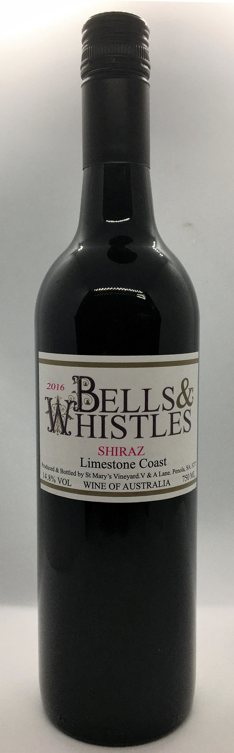

St. Mary’s Vineyard is planted on it’s own unique area of terra rossa soil over limestone and is located 16 km to the west of the Penola township in the south-east of South Australia.

The 2016 vintage conditions have produced exceptional fruit colour and character.

2016 Shiraz has a complex floral nose, with hints of raspberry, rose petals and soft spice.

Black currant and cherry on the palate with a soft, smooth mouth feel. A wine of overall richness and structure and will last for years to come.

Aged in American and French oak.

This wine is another fine result of the interna- tionally recognized combination of Terra Rossa soil, the limestone sub-base and cool cli- mate of the region.

St Mary’s Wines

V&A Lane, Penola, SA, 5277 PO Box 14, Penola, SA, 5277

Ph:+62 (08)87366070 Fax: +61 (08) 87366045 [stmaryswines@bigpond.com](mailto:stmaryswines@bigpond.com) [www.stmaryswines.com](http://www.stmaryswines.com/)