**2023 Fulcrum**

**Victorian Pinot Noir**

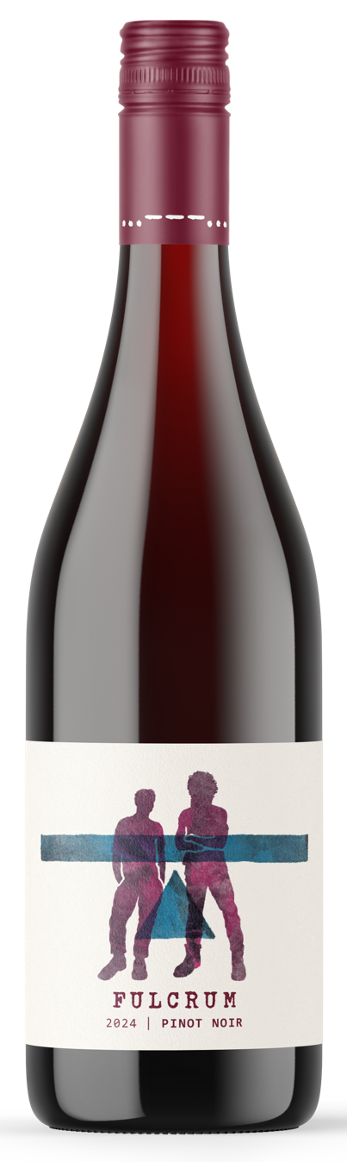Fulcrum Pinot Noir embodies the collective experience of William and Jason, who have spent over 30 years working with and enjoying the nuances of Victorian Pinot Noir. Their journey, marked by learning from the ever-evolving character of the grape, comes to fruition in this vibrant wine.

In 2023, the duo sought out the Dalbosco family, who grow Pinot Noir in Victoria’s 'High Country'—the Alpine Valleys. This renowned region is celebrated for its ability to produce fruit that exudes aromatic complexity, lively characters, and a deep, rich cherry profile.

The other component of the wine is from the Yarra Valley’s Dixon’s Creek, an area known for its plumy, fleshy fruit. Nearly 55% of the blend comes from two 30-year-old vineyards in Dixon’s Creek, with the balance sourced from the Dalbosco vineyard, adding aromatic complexity from the Alpine Valleys.

The result is a bright, medium-weight Pinot Noir, featuring fresh raspberries, ripe plums, and currants. Subtle spice and depth from the combination of regions complete the profile, making this a wine that celebrates both the heritage and craftsmanship of Victorian Pinot Noir.

All parcels were vinified separately. Fruit was destemmed into large static fermenters for chilling and a short cold soak before inoculation and a 10-day ferment on skins with minimal pumping over to retain freshness. No oak treatment during elevage. Final blend in July 2023 before bottling in August. Release in February 2025.