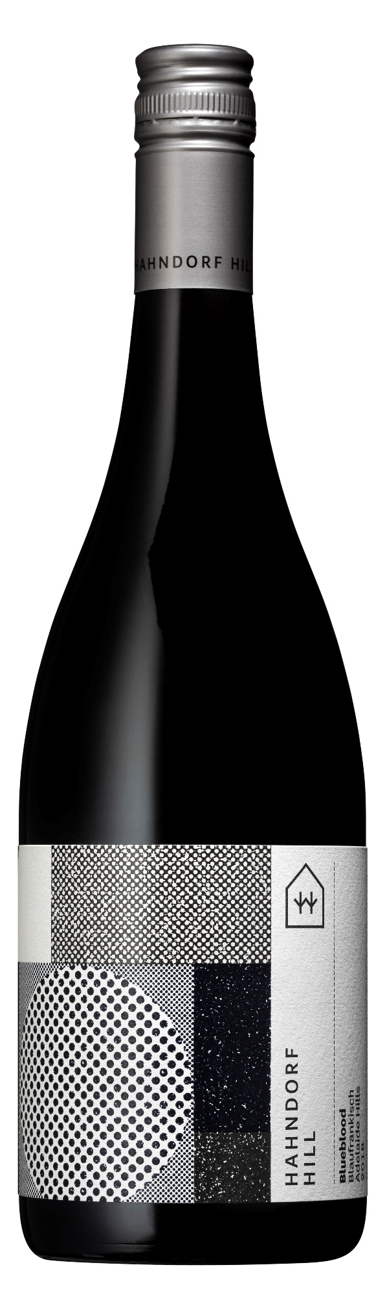

ADELAIDE HILLS

**Blueblood Blaufrankisch 2019**

Gold Medal - London Wine Competition 2022

Gold Medal - Berliner Wein Trophy 2021, Germany

Silver Medal - AWC Vienna International Wine Challenge 2021, Austria

Blaufrankisch is the prestige red grape of Austria, and Hahndorf Hill was the first producer of this variety in Australia.

Hand-harvested at a yield of 3.3 tonnes per acre from our Hahndorf vineyard, and after crushing and destemming, the juice was split into two parcels – one for cold maceration prior to fermentation, and the second half for wild fermentation.

The wine was aged for 11 months in 20% new French oak barriques selected for their ultra-tight wood subtlety, and the balance in older French barriques.

This wine is hauntingly beautiful and gentle with an appealing nose of blue-brambly fruit and spicy black cherries. Extraordinarily smooth and fine on the palate with an elegant tumble of fruit and a juicy acidity that’s perfectly framed by mouth-filling ripe tannin.

Match this wine to skillet-seared lamb, crispy duck or Atlantic salmon. This wine is also fearless when matched to any spicy meat or vegetarian dishes!

**Lab data:**

**pH: 3.53 TA: 6.1 G/L**

**Resid. Sugar: 0.3 G/L**

**Alc: 13.0%**