

St Mary’s Wines

*Basket Pressed*

2019 ‘Bells and Whistles’ Cabernet Sauvignon

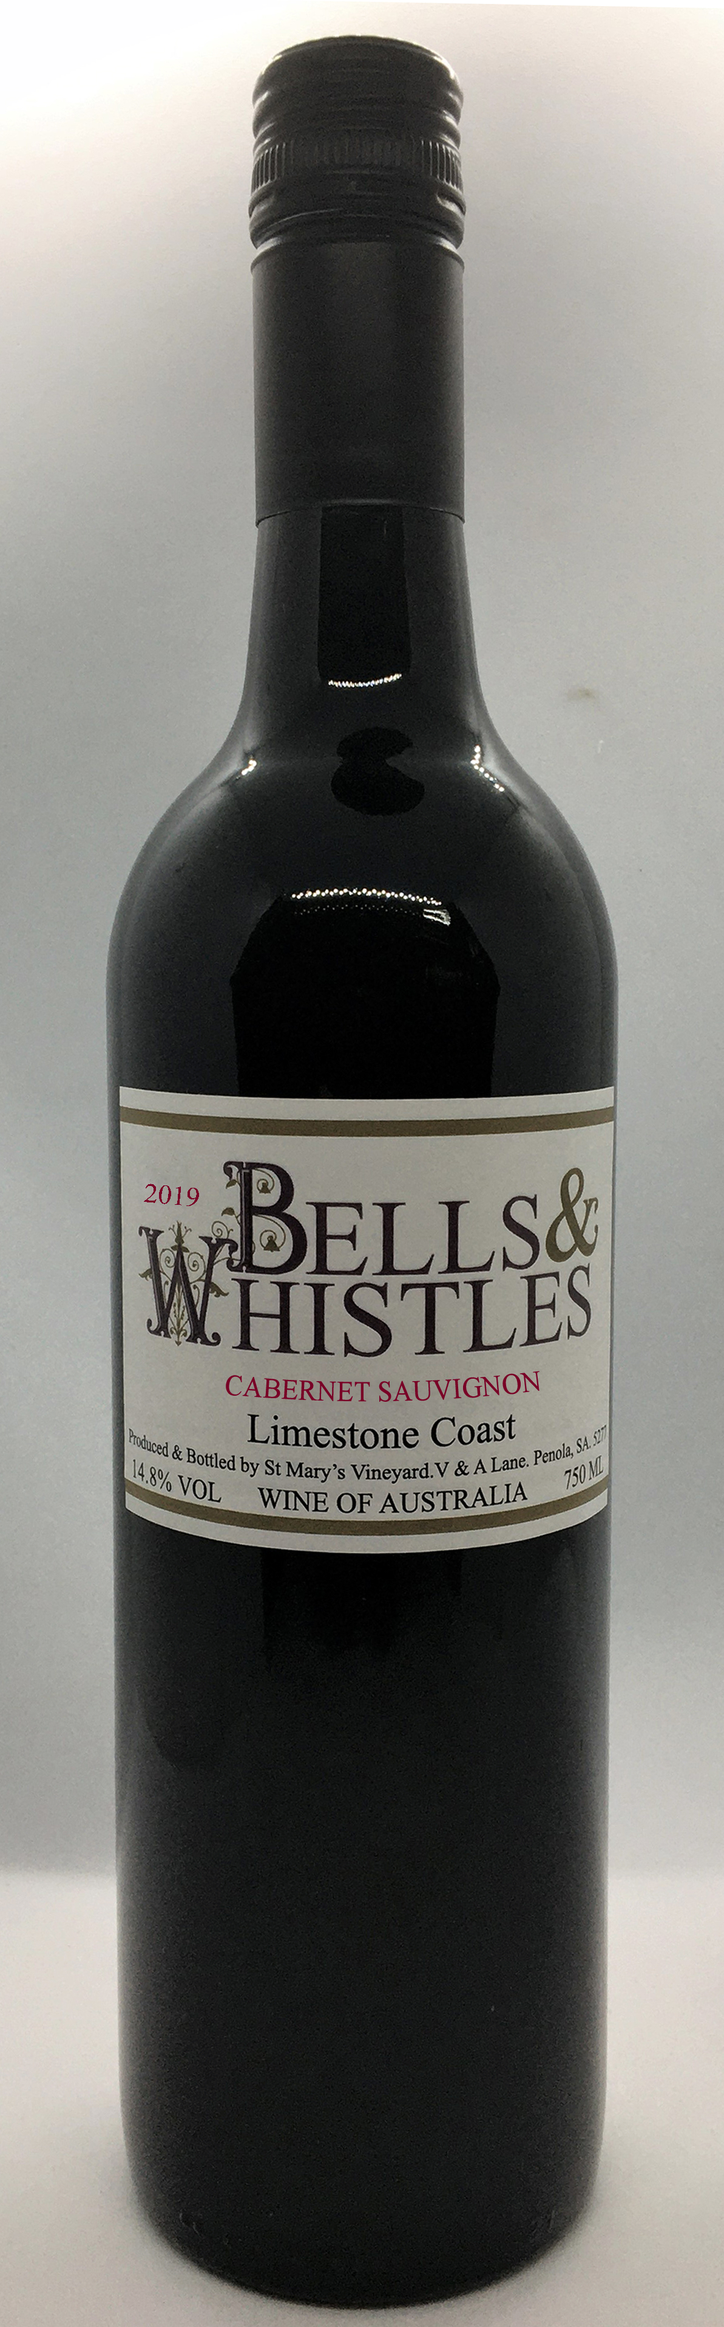

St. Mary’s Vineyard is planted on a unique

area of elevated terra rossa soil over limestone. The vineyard is located 16km to the west of

the Penola township in the south-east of South

Australia.

The 2019 vintage conditions have produced exceptional fruit colour and character.

The 2019 Cabernet Sauvignon is packed with character. Deep purple hues, black currant and mint aromas with a hint of spice.

An excellent balance of ripe fruit, subtle pep- per, with a touch of mint and chocolate. Soft round tannins compliment a richness that will last for years to come.

Aged in French oak.

This wine is another fine result of the interna- tionally recognized combination of Terra Rossa Soil, the limestone sub-base and the cool cli-

mate of the Penola region

St. Mary’s Wines

V&A Lane, Penola SA. 5277. P.O. Box 14, Penola, SA. 5277

Ph. 08 87366070 Fax. 08 87366070

[stmaryswines@bigpond.com](mailto:stmaryswines@bigpond.com) [www.stmaryswines.com](http://www.stmaryswines.com/)