**Hahndorf Hill** Blaufrankisch

Hahndorf Hill is the first producer of Blaufrankisch in Australia.

This is a hauntingly attractive wine with black cherries, blueberries, fennel and spice. Beautifully smooth on the palate, yet has excellent structure, juicy acidity and extraordinary elegance. It is an amazingly good food wine and is well matched with beef, lamb and duck - but equally magical with vibrant, spiced meat dishes such as oven-grilled Italian farmer’s sausage or a tasty Beef Rendang.

**Previous awards and reviews for this wine:**

95 Points – James Halliday: **“… a totally delicious, supple, medium-bodied palate with a Joseph's coat array of flavours ranging from cedar and tobacco through to a silky red cherry finish.” (2012)**

Gold Medal **- AWC Vienna International Wine Challenge, Austria (2011)**

Top 100 Wines **- The Advertiser (2011)**

Trophy / Top of Class / Gold Medal **– Australian Boutique Wine Awards (2010)**

Gold Medal **- International Cool Climate Wine Show 2010**

Trophy / Top of Class / Gold Medal **- Australian Boutique Wine Awards (2009)**

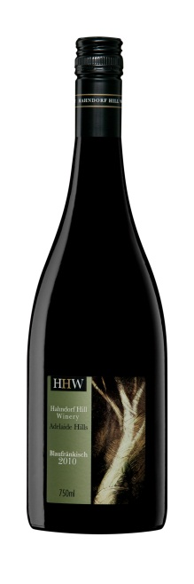

**Hahndorf Hill** Gruner Veltliner

Hahndorf Hill was the first Gruner Veltliner producer in South Australia! This classic Austrian grape is reputed to make the world’s most food-friendly white wine.

This is a captivating wine with vibrant aromatics and spice and which has a shimmering, crystalline quality. The palate is all about purity, minerality and texture and has excellent mouth-feel. The fruits are citrus, apple and pear with hints of tobacco and caramelised parsnip and there is an exotic spritz of white-pepper spice in the tail.

**Previous awards and reviews for this wine:**

**Hot 100 Wines, The Adelaide Review: ‘… palate texture feels like ice-skating.” (2011)**

**93 Points – Nick Stock, Good Wine Guide (2011)**

**94 points – Philip White, The Independent Weekly: “Very few wines manage such an exquisite balance of fleshy sensuality and mineral austerity …” (2010)**

**93 Points – Tim White, The Australian Financial Review (2010)**

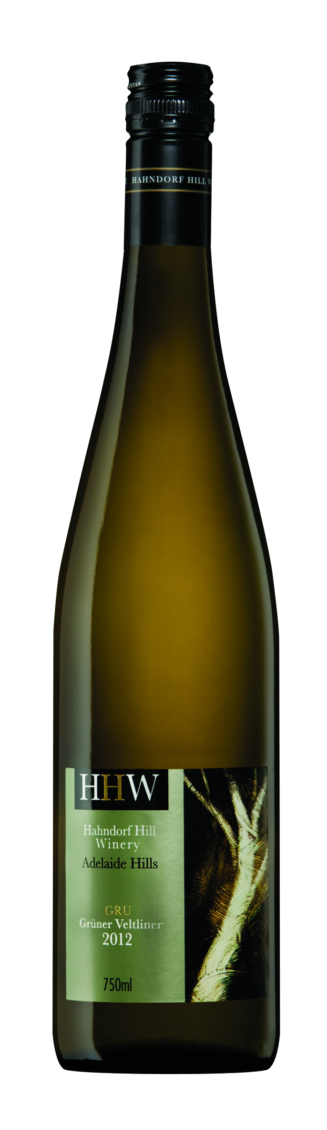

**Hahndorf Hill** Rosé

This dry Rosé is made from hand-harvested ***Trollinger*** and ***Blaufrankisch*** grapes. Gorgeous salmon pink colour with mouth-watering boiled-sweet aromas of quince and wild strawberries. Juicy flavours flow onto the palate together with an appealing freshness and excellent structure. This wine is the perfect match for your favourite seafood and all spicy Indian, Italian and Thai cuisine.

**Previous awards and reviews for this wine:**

**Bronze Medal - Adelaide Hills Wine Show (2011)**

**90 Points – James Halliday: "... the palate is intense and markedly long, with savoury quince flavours, the finish well-balanced.” (2010)**

**91 Points – Huon Hooke, Sydney Morning Herald (2009)**

**‘Pink with attitude’ – Tony Love - The Advertiser (2009)**

**Bronze Medal – Rutherglen Wine Show (2008)**

